Template master test plan

Version information
Version | Date | Remarks | Author
1.0 | 22.08.2021 | Master Test Plan Initialization | Michael Weisang

Distribution list
Name | Company/Function

Approval Client

Client: |  | Signature
Name
Division
Department
Function
Location
Telephone
E-Mail address |  | Date:

Management summary
Project objective
Developing a social media platform that help decrease mental health issues during COVID.
Test objective and assignment
Ensure that the product is up to the standard
Short description of the test approach

Results to be realized
Result  - System is working properly  - User can use and enjoy the website properly  - Website is ready to be launched |  | Document  - ST Test report  - UAT Test report  - End report Testing | Delivery date
Qualitative objectives
Each test levels need to be satisfied
Each test is done thoroughly
Estimate
2-3 weeks
Test process risks and measures
Test process risks  - Low diversity user testing  - Incorrect Scheduling | Measures to be taken  - Increased number of testers  - Provide a buffer deadline
Table of Contents
1 Introduction 1
1.1 Project and project objective 1
1.2 Objective of the master test plan 1
1.3 Involved in creating the master test plan 1
2 Assignment formulation 2
2.1 Client 2
2.2 Supplier 2
2.3 Assignment 2
2.4 Scope 2
2.4.1 Within scope 2
2.4.2 Out of scope 2
2.5 Preconditions and assumptions 3
2.6 Acceptance and acceptance criteria 3
2.6.1 Acceptance 4
2.6.2 Acceptation criteria 4
3 DOCUMENTATIONS 5
3.1 Basis for the master test plan 5
3.2 Standards 5
3.3 Test basis 5
4 Test strategy 6
4.1 Product risk analyses 6
4.2 Test strategy 7
5 APPROACHES 9
5.1 Test levels 9
5.2 Evaluation 9
5.3 The <name test level> 9
5.3.1 Goal 9
5.3.2 Short description 9
5.3.3 Responsible 9
5.3.4 << Optional: test environment to be used >> 10
5.4 Phasing per test level 10
5.5 Test products 11
5.6 Review plan 11
5.7 Entrance and exit criteria for each test level 12
5.7.1 << Optional: Functional Acceptance Test >> 12
5.7.2 << Optional: User Acceptance Test >> 12
5.8 Go/No go 12
6 Organization 14
6.1 Organization structure 14
6.2 Roles, tasks and responsibilities 14
6.2.1 << Optional: Trainings- and coaching’s necessity >> 14
6.3 Structure of meetings 14
6.4 Structure of reporting 15
6.5 Completion 15
7 INFRASTRUCTURES 16
7.1 Test environments 16
7.2 Test tools 16
7.3 Office setup 17
8 Management 18
8.1 Test process management 18
8.2 Test infrastructure management 18
8.3 Test product management 18
8.4 Defects procedure 18
9 Test process risks and countermeasures 19
10 Global Estimation & Planning 20
10.1 Estimation 20
10.9 Planning 20
10.10 Milestones 21
11 Glossary 22

Introduction

Project and project objective
This master test plan is designed specifically for the project plan Naaman. Project Naaman is a website development project aiming to create a social media platform to combat the rising issue of people’s mental health during the social distancing.

Objective of the master test plan
The objective of the Master Test Plan (MTP) is to inform all who are involved in the test process about the approach, the activities, including the mutual relations and dependencies, and the (end) products to be delivered for the test project Naaman
The master test plan describes this approach, the activities and (end) products that need further elaboration in the other system test plans. These system test plans need to be abstracted from this master test plan.

Involved in creating the master test plan
Name | Function | Responsibility
Group 2 “Runtime Terror” | Developing the master test plan | Creating the master test plan
Ather Saeed | Provide guidances | Reviewing the master test plan
Client | Approval | Approve the master test plan

Assignment formulation

Client
<The client is>

Supplier
Group 2 “Runtime Terror”
Project team | Contact information
Sobana Handi Achini Thisarangi De Silva | achinithisarangi86@gmail.com
Dehemi Vihara Dissanayake Liyanage | dissanayake7793@gmail.com
Gaury Chethana Thanthirigama | chethana9804@gmail.com
Temuulen Tsengel | temuulen2830@gmail.com
Michael Weisang | weisangm1@gmail.com

Assignment

Scope

Within scope
User interface
Admin interface
System integration and functionality
Testing
System capability

Out of scope
Anything not mentioned in scope

Preconditions and assumptions
Preconditions concern conditions that third parties like the client, the project or the users, impose to the test process and within which the test process must operate (definition TMap® Next). The following demands are enforced:
- The user testers need to have no prior knowledge to the user interface design
- The test should be commencing without any bias
- The business requirement is final
- All parts are included in the test
- Tester environment is clear of bias influenced

Assumptions are external circumstances or events that must occur to ensure the test process’ success, but that cannot be controlled by the test process. In other words, these are the requirements of the test process vis-à-vis others (definition TMap® Next).

- All deliverables are completed
- All unit are accessible

Acceptance and acceptance criteria
<< See TMap® Next 5.2.2 >>

Acceptance
The table below states the acceptance of Naaman:

Name | Function | Department

Acceptation criteria
The table below states which acceptance criteria there are for Naaman and to which standard they should apply:

Description | Standard
Website accessibility | WCAG 2.0
Medical Devices Software | IEC 62304

DocumentatiON
This chapter describes the documentation used in relation with the master test plan. The described documentation concerns a first inventory and will be elaborated, actualized and detailed at a later stage, during the separate test levels.

Basis for the master test plan
<< Consider a Project plan or a Plan of Approach for the project, specific project or test planning, an implementation plan or other documents of importance. >>

The following documents are used as basis for this master test plan.

Document name | Version | Date | Author
IEC 62304
Tmap master test plan | 1 |  | Tmap

Standards
<< With regards to testing consider TPI or test guide books. Development standards, documentation standards or quality conventions can also be used. >>

The following conventions and standards are applied for this test plan.

Document name | Version | Date | Author
TMap® Next for result driven testing | 1e edition | 2006 | T. Koomen, L. van der Aalst, B. Broekman en M. Vroon
WCAG | V2.0 | 2008 | Ben Caldwell, Michael Cooper, Loretta Guarino Reid, Gregg Vanderheiden
IEC 62304 |  |  | IEC

Test basis
The test basis contains the documentation that serves as basis for the tests that have to be executed. The overview below describes the documentation that is the starting point for testing.

Document name | Version | Date | Author

Test strategy
The time available for testing is limited; not everything can be tested with equal thoroughness. This means that choices must be made regarding the depth of testing. Also, it is strived to divide test capacity as effective and efficient as possible over the total test project. This principle is the basis of the test strategy.

The test strategy is based on risks: a system must function in practice to an extent that no unacceptable risks for the organization arise from it. If the delivery of a system brings along many risks, thorough testing needs to be put in place; the opposite of the spectrum is also true: 'no risk, no test'.

The first step in determining the test strategy is the execution of a product risk analyses. This is elaborated in §4.1.

The test strategy is subsequently based on the results of the risk analyses. The test strategy lays down what, how and when (in which test level) is being tested and is focused in finding the most important defects as early as possible for the lowest costs. This can be summarized as testing with an optimal use of the available capacity and time. The test strategy is described in §4.2.

Product risk analyses
The product risks are determined in cooperation with the client and the other parties involved. This product risk analyses (PRA) is comprised of two steps:
- Make an inventory of the risks that are of interest
- Classify the risks.

The complete product risk analysis is mentioned in appendix.

During the risk assessment the test goals were also formulated. These can be found together with the corresponding characteristics in table below.
Test goal | Description | Characteristic
System performance | How the system performs when fully integrated | Performance
Friendly User Interface | User interface should promote a comfortable and soothing feeling | User Interface
Ease of use | System should be easy to use | User friendliness

The acceptant have determined the product risks. The extent of the risk (the risk class) is dependent on the chance of failure (how big the chance is that it goes wrong?) and it depends on the damage for the organization if it occurs.

The risk class (RC) determines the thoroughness of the test. Risk class A is the highest risk class and C is the lowest. The test strategy is subsequently focused on covering the risks with the highest risk class as early as possible in the test project.

First the chance of failure and damage are determined for each risk. The risk class has been taken directly from this. <<Note: This is the contents from the TMap® Next table (See TMap® Next 9.6). Evidently it’s possible to deviate from this in consultation with the client.>>.

Risk table
Characteristic | Part | RC | Argumentation
Functionality | … | A/B/C | …
User-friendliness
Performance
Security
Suitability
Etc.

Test strategy
For each risk from the product risk analysis the risk class is qualifying the thoroughness of the test. Risk class A is the highest risk class and C the lowest. The test strategy is subsequently focused on covering the risks with the highest risk class as early as possible in the test project.
Characteristic /object part | PRA-RC | Evaluation | Development test | ST | FAT | UAT | Impl
System Functionality | A |  | S |  |  |  | 
User Interface Design | B |  |  |  |  | 
User-friendliness | B |  |  |  |  | 
Performance | B |  |  |  |  |  | 
Supportability | B |  |  |  |  |  | 

<Explanation for the table above:
PRA-RC | Risk class (from product risk analysis, where A=high risk, B=average risk, C=low risk)
Evaluation | Evaluation/review of the various intermediary products (requirements, functional design, technical design)
Development test | Unit test and Unit integration test
ST | System test
FAT | Functional acceptance test
UAT | User acceptance test
Impl | Implementation
 | Limited thoroughness of the dynamic test
 | Medium thoroughness of the dynamic test
 | High thoroughness of the dynamic test
S | Static testing (checking and examining the products without executing the software
I | Implicit testing (including in another test type without creating specifically designed test cases
<blank> | If a cell is blank, it means that the relevant test or evaluation level does not have to be concerned with the characteristic
>

Approach
In this chapter each test level in the test strategy (the what) will be translated to a concrete test approach (the how).

Test levels
For this MTP the following test levels are acknowledged:

Test level | Goal
Unit Test | Early testing to make sure the unit created is working
System Test | System test to make sure the whole unit is integrated properly
Functional Acceptance Test | Making sure that the product met the quality standards
User Acceptance Test | User testing to ensure the user experiences

Evaluation
<< Describe the evaluation strategy, if evaluation belongs to the scope of this master test plan. >>

The <name test level>

Goal
<< What is the goal of the test level. >>

Short description
<< Short description on the contents of the test level (what characteristics, who specifies, what test goals are covered, who executes and on which kind of test environment). Subsequently describe for each characteristic how the risks concerned are being verified and/or tested for this test level. >>

Responsible
<< The responsible and/or people involved or department for the execution of the test level. Consider the following:
- The test manager is actually responsible for these tests: in that case there should not be anyone else mentioned as responsible. In that case it concerns the 'involved' or, even better, the 'executers' (from that external party), who are managed by the test manager (otherwise the test manager can’t be responsible)
- The test manager is not responsible for these tests (in that case these tests or test levels have to be listed in §2.4.2 “Out of scope”): it is possible to make certain demands (mainly in the form of exit criteria that have to be met) to these tests, naturally after obtaining agreement with the external parties.
- The test levels concerned are described in the test strategy of the MTP, but the test manager is not responsible for these tests. He is responsible for obtaining agreement regarding the tests with the external parties, as well with the realization of the test strategy and with the execution of it, but not for the result and quality of these tests, as he has no mandate in this. Appoint this construction explicitly with paragraph 2.4.1 and 2.4.2 (In that case the design of the test strategy is within scope and is including the 'external tests' and verification of the exit criteria. Out of scope is the actual management and execution of these tests).
See for more in chapter 6 of this MTP. >>

<< Optional: test environment to be used >>
<< The <test level> will be executed on the <test environment>. This will be elaborated in chapter 7. >>

Phasing per test level
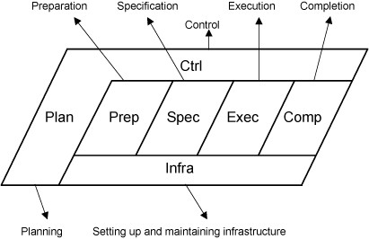

In the Planning phase, the test manager formulates a coherent approach that is supported by the client to adequately execute the test assignment. This is laid down in the test plan. In the Control phase the activities in the test plan are executed, monitored, and adjusted if necessary. The Setting up and maintaining infrastructure phase aims to provide the required test infrastructure that is used in the various TMap phases and activities. The Preparation phase aims to have access to a test basis, agreed with the client of the test, of adequate quality to design the test cases. The tests are specified in the Specification phase and executed in the Execution phase. This provides insight into the quality of the test object. The test assignment is concluded in the Completion phase. This phase offers the opportunity to learn lessons from experiences gained in the project. Furthermore activities are executed to guarantee reuse of products.

Test products
<< See TMap® Next 5.2.7 >>

The deliverables are:

Phase | Product | Comment | Delivery Date
<Planning> | <Master test plan>
 | <Test plan for each test level>
<Management> | <Risk report>
<Setting up and maintenance infrastructure> | <Detail specification test environment>
<Preparation> | <Report detail intake for each test level>
<Specification> | <Test script pretest>
 | <Test script for each test level>
 | <Test script for each test level>
<Execution> | <Defect log>
 | <Status report>
<Completion> | <End report>
 | <Release advice (for each test level)>

Review plan
List the deliverables that must be reviewed by the stakeholders.

Deliverable | Authors | Type review | Reviewers
Master Test Plan | Group 2 “Runtime Terror”
Test Plan | Group 2 “Runtime Terror”
End Report | Group 2 “Runtime Terror”

Organization
Organization

Organization structure
Completer (attention to detail) | Sobana Handi Achini Thisarangi De Silva
Resource Investigator (explore opportunities and contacts) | Dehemi Vihara Dissanayake Liyanage
Shaper (drive team forward) | Gaury Chethana Thanthirigama
Coordinator (clarify goals, promote decision making) | Temuulen Tsengel
Leader (provide support and encourage cooperation) | Michael Weisang

Roles, tasks and responsibilities
Describe for each role the tasks and the responsibilities.
<< Describe for each role which department/who will fill these positions, for how many hours per week and during what period. >>
Role | Department / Name employee(s) | # hours  per week | Period | Description of tasks and  responsibilities
Test manager | Group 2 “Runtime Terror” | 10 |  | Write MTP  Coordinate overall test process
Test coordinator | Group 2 “Runtime Terror” | 10 |  | Write test plan  Coordinate test
Tester “user” | Voluntary | 1 |  | Execute UAT
Tester | Group 2 “Runtime Terror” | 5 |  | Execute test

Structure of meetings
Mention all types of meetings within the test project, the objective of the meeting, the frequency and who needs to be present.

Type | Goal | Frequency | Who
<Project meeting> | <Discuss overall project progress > | <Weekly> | <Project manager  Test manager>
<Progress meeting for each test level> | < Discuss progress for each test level> | <Weekly> | <Test manager  Testers>
<defect triage> | <Discuss and prioritize defects found during test> | <Weekly> | <Test manager – owns>  <Technical lead>  <Project Manager>  <Business lead>

Structure of reporting
Mention all types of written communication.

Type | Goal | Frequency | Who
<Risk report> | <Gives insight in the recognized risks of the tests> | <Ad-hoc> | <Test team>
<Release advice> | <Gives advice about quality/risks of the implementation of the test object> | <Once-only> | <Project manager>
<End report> | <Gives insight in the evaluation of the test process and test object> | <Once-only> | <Project manager>
<Progress report> | <Gives insight in the progress of thee tests and quality/risks of the test object> | <Weekly> | <Test manager to key stakeholders>
<Defect reports> | <Gives insight to defects and their status’. > | <Weekly> | <Test manager to key stakeholders>

Completion
This describes the procedures for the completion process at the end of the project.

Infrastructure

Test environments
<< Describe the demands that each test level makes to the corresponding environment. Mention here a description of the infrastructure components, test data/ files. Consider the demands that are being made from the test strategy and approach to the test environment.

Mention when each environment has to de delivered, and for how long this environment is needed. Refer to §8.2 where the management of the test infrastructure is described. >>

Test level | Environment | Requirements | From | To
<ST>
<FAT>
<UAT> | Isolated users | Computer with browser and internet access

Test tools

Test level | Test tool | Comment
ST | Eclipse/netbeans IDE
UAT | Browser  Time watch  Feedback sheet

Office setup
Processor (CPU): | Intel Core i3 (third generation or newer) or equivalent
Operating System: | Microsoft Windows 10
Memory: | 8 GB RAM
Storage: | 500 GB internal storage drive
Monitor/Display: | 14" LCD monitor, resolution of 1600 x 900 or better.
Network Adapter: | 802.11ac 2.4/5 GHz wireless adapter

Management

Test process management
The management of the test process can be divided into three parts:
- Progress and expenditure of budget and time: the management of the planning and guarding of the progress in terms of time, resources and means. This has been arranged as followed: < short description >;
- Quality indicators: the aim of testing is to provide information and advice on the risks and quality of the object to be tested. To be able to provide this information, quality indicators are registered. This has been arranged as followed: < short description >.
- Test statistics: the test manager builds statistics based on the above information. Statistics can supply insight into the progress of the test process and quality of the test object, including any trends. This has been arranged as followed: < short description >.

Test infrastructure management
<< Describe how and by whom the test infrastructure is managed:
- Procedure office setup
- Procedure test tool
- Procedure test environment

Describe for each system part (platform, database, software, etc.) what authorizations are needed for the test team. During which period they are needed, and who’s responsible. See TMap® Next 6.4.5. >>

Test product management
<< Describe how the test products, conventions and standards, will be maintained and guarded. Do this using procedures, templates and tools. Consider:
- Products like testware and test project documents
- External products like the test basis and object under test >>

Defects procedure
The defects management has been arranged in conformity with the defect procedure that is described in TMap® Next 12.4., or in conformity with defect procedure as it is used within the organization. For the registration and maintenance of defects the following tool is being used: < tool >.
The responsibility for the observance of this defects procedure lies with the <defect administrator>.
<< Diagram TMap® Next p. 568. >>

Test process risks and countermeasures
This chapter makes an inventory of the most important potential project risks for the testing of <Name project>. By anticipating what possibly might occur, it’s possible to mitigate the risk by taking the appropriate countermeasures. The risks apply directly to the test process, or apply to risks that can be of direct consequence for the test project. Registration and monitoring of these risks continues after the MTP has been written, it is a continuous process.

The following risks have been recognized for the test process. See also <name risk log>.

Nr | Risk Event | Consequence | Impact | Chance | Score | Countermeasures | Owner

The test manager is aware of these points and monitors the countermeasures.
<< The countermeasures that can’t be taken within the test organization can be discussed and assigned owners during the project meeting. This will be recorded in the action list and is monitored during the project meeting. See TMap® Next, 5.2.11. >>

Global Estimation & Planning

Estimation
The estimation is as follows:

Test level | Who | P | C | I | P | S | E | C | Totals
Overall | Group 2 “Runtime Terror”
ST | Group 2 “Runtime Terror”
FAT | Group 2 “Runtime Terror”
UAT | Tester “User”
Totals:

This estimation will be divided in sub activities in the detail test plans for each test level.

Planning
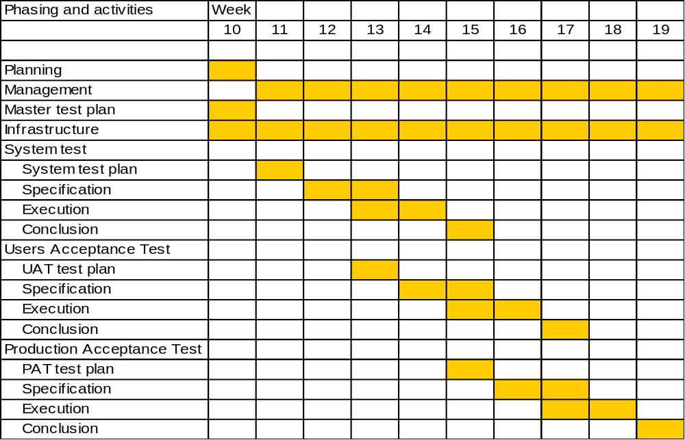

The activities to be executed are in the table below.

Activity | Name | Start Date | End Date | Duration | Relations

Milestones
The milestones of the test process of <system> are detailed in the table below.

Mile stone description | Date
<< Think of the defined products from §5.5 >>

Glossary
PRA | Product risk analysis; analyzing the product under test with the goal that the test manager and the other stakeholders achieve a joint view of what the more and less risky parts and characteristics of the system are. This with the purpose to relate the thoroughness of testing to it.
ST | System test, by the vendor of the solution in a (good controllable) laboratory environment executed test, which has to demonstrate that the developed system or parts of it comply with the functional and non functional specifications and the technical design.
UT | Unit test, by the developer in the development environment executed test, which has to demonstrate that a unit complies with the technical specifications.
DTAP | Development, Test, Acceptance and Production environment in a so called following, logical ‘street’.

